HTML CODE FOR IMAGE-GALLERY to display movies

Defination :-> An ImageGallery is a list / group of an images

<!DOCTYPE html>

<html lang="en">

    <link rel = "stylesheet" href="Assignment3.css">

<head>

    <meta charset="UTF-8">

    <meta name="viewport" content="width=device-width, initial-scale=1.0">

    <title>Document</title>

</head>

<body>

    <h1> IMAGE GALLERY</h1>

    <hr>

    <div class ="gallery">

        <img class = "image"src = "Screenshot 2024-05-25 115846.png" alt ="Loading">

        <img class = "image"src = "Screenshot 2024-05-25 115911.png" alt ="Loading">

        <img class = "image"src = "Screenshot 2024-05-25 120128.png" alt ="Loading">

        <img  class = "image"src = "Screenshot 2024-05-25 120154.png" alt ="Loading">

        <img  class = "image"src = "Screenshot 2024-05-25 120220.png" alt ="Loading">

        <img  class = "image"src = "Screenshot 2024-05-25 120254.png" alt ="Loading">

        <img  class = "image"src = "Screenshot 2024-05-25 120254.png" alt ="Loading">

        <img  class = "image"src = "Screenshot 2024-05-25 120337.png" alt ="Loading">

        <img  class = "image"src = "Screenshot 2024-05-25 120414.png" alt ="Loading">

        <img  class = "image"src = "Screenshot 2024-05-25 120754.png" alt ="Loading">

        <img  class = "image"src = "Screenshot 2024-05-25 120842.png" alt ="Loading">

        <img class = "image"src = "Screenshot 2024-05-25 115846.png" alt ="Loading">

    </div>

</body>

</html>

CSS CODE FOR ImageGallery

body{

    background-color:blanchedalmond;

}

h1 {

    text-align: center;

    color :brown;

}

div {

    height : 500px;

    width : 860px;

    border : 2px solid black;

    margin : 0 auto;

    display: grid;

    grid-template-columns: repeat(auto-fill,minmax(200px,1fr));

    row-gap : 20px;

    padding : 20px;

}

img {

    height : 150px;

    width : 200px;

    margin-left: 2opx;

    border : 1px solid black;

    border-radius: 10px;

}

.image:hover {

  box-shadow: 4px 4px 3px orange;

}

hr{

    border : 1px solid white;

    margin-bottom: 50px;;

}

OUTPUT :->

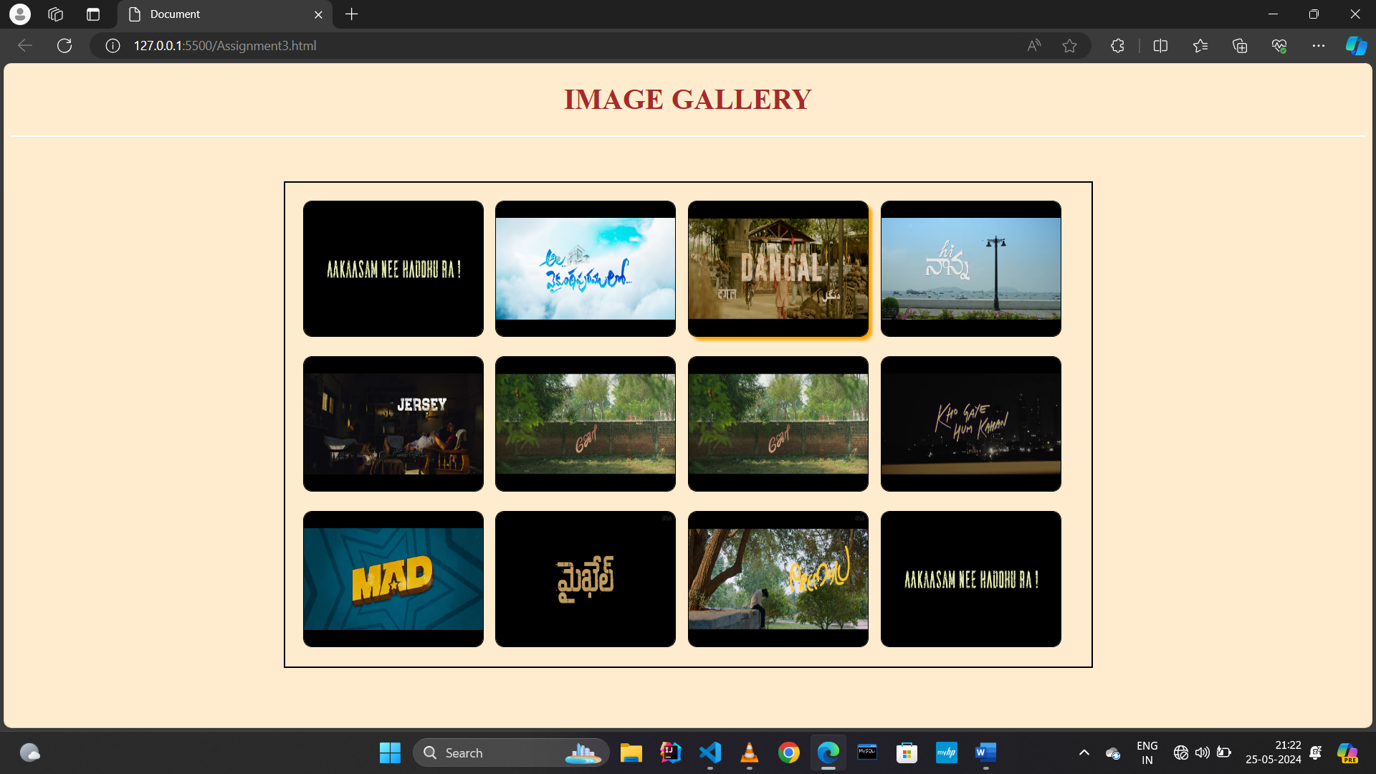

Hover Affect 🡪 (Appled for all Images)

